Scientific Data Visualization
Project Title: Sleep Health Life Cycle Productivity

Team Members:
- Venkata Bhargavi Nalamothu
- Vignesh Nallamothu
- Vishnu Sai Gorantla
- Naveen Kumar Kolla

1. Workflow Diagram
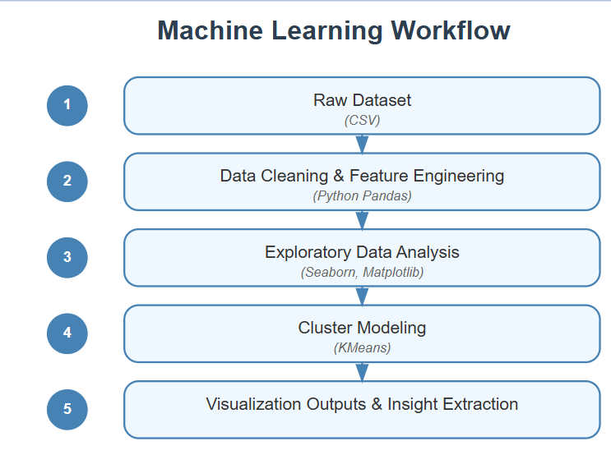

The workflow demonstrates an easy machine learning process which follows five distinct steps from start to finish.

Raw Dataset (CSV) - The starting point with original data

Data Cleaning & Feature Engineering (Python Pandas) - Preparing the data

Exploratory Data Analysis (Seaborn, Matplotlib) - Understanding patterns

Cluster Modeling (K-Means) - Creating the machine learning model

The extraction of results along with insights occurs during this step.

The workflow follows an accumulated process that utilizes blue arrows to illustrate data acquisition up to final insights. The analysis process follows a clear roadmap through the steps which lists the implemented tools in parentheses.

2. Related Work
- The evidence presented in academic research and health publications shows the National Institutes of Health (NIH) and Stanford Sleep Study together with other reputable institutions emphasize sleep's strong impact on human body performance.
- Multiple academic publications from NIH and Stanford Sleep Study have demonstrated that sleep acts as a fundamental factor which promotes cognitive abilities and maintains emotional equilibrium to improve work performance.
- The visual strategy emerged directly from discovered data correlations through these research studies. Our research approach uses fundamental sleep-related findings to create visual exposure of sleep patterns and performance indicators relationships.

3. Data Abstraction

Type and Attributes:

The dataset includes a mix of quantitative and categorical attributes that provide a comprehensive view of individual sleep and productivity patterns.

- Quantitative features include metrics such as sleep hours, productivity score, stress level, and caffeine intake.
- These continuous variables allow for detailed numerical analysis and comparison.
- On the other hand, categorical attributes such as gender, sleep category, stress category, and cluster labels facilitate segmentation and classification within the dataset

Detailed Description:
- This study drew its data from the “Sleep Cycle and Productivity Dataset” on the Kaggle platform. The dataset contains 5001 records which create sufficient statistical and visual analytical capacity.
- The dataset contains varied information including life-style variables (screen time and exercise) combined with health indicators (stress levels and mood) together with productive activity measures.
- Various attributes contained in the dataset allow researchers to study the sleep-performance connection through multiple analytical dimensions.

Feature Design:
- The research team created multiple specific characteristics to boost the analytical capabilities of the database. These include:
- The sleep category reorganizes uninterrupted sleep data through categorized periods which produce meaningful sleeping intervals.

- The creation of grouped stress categories used the same binning approach as stress level collection.
- A derived analytic metric called MoodProductivityGap represents the performance difference between employee ratings of their mood versus their productivity at work.
- K-Means clustering function produced Cluster which sorted records into separate behavioral patterns using common features between them.

Data Transformation:

- For data analysis preparation multiple preprocessing procedures were executed.
- The data processing included handling null values that led to consistent and complete datasets.
- Numerical columns received proper type conversion that maintained suitable data types necessary for running mathematical operations.
- Normalized data processing applied to chosen features so clustering results could be optimized while keeping features comparable at varying scales.

4. Task Description
Target & Actions:
- The main goal of this project entails obtaining complete insights about the relationship between sleep quality and habits to productivity levels. Several defined targeted actions will lead to this achievement.
- The research will establish how multiple aspects of sleep duration and quality affect work performance among individuals in the workplace.
- The analysis aims to detect meaningful relations between stress levels and productivity scores along with mood ratings since this effort seeks to identify underlying trends in behavioral or psychological domains.
- A specific sleep pattern-related to enhanced work productivity emerges from segmentation and clustering methods thus defining the characteristics of optimal sleep behaviors.
- The design offers interactive visual tools which allow users to minimize datasets according to their levels of stress and sleep quality thus maximizing their examination of special user clusters or stress situations.

5. Tools Description
Data Processing:

The project leverages a set of powerful Python-based tools for data processing:

- The application of Python (Pandas) covers all aspects of data cleaning alongside data transformation through operations such as handling missing data points and transforming data types before conducting analysis.

- The KMeans clustering method from Scikit-learn splits the data into separate groups through the analysis of patterns displayed by similar behaviors.

Visualization Tools:

Multiple visualization tools help the researchers effectively explain their outcomes by presenting data in an easy-to-understand format.

- Matplotlib/Seaborn generates static plots to present data communication through trends distributions and relationship observables in the dataset.

- The main analysis environment in Jupyter Notebook provides users step-by-step interactive access along with documentation capabilities for the analysis process.

6. Visualization Graphs

# http://0.0.0.0:8000/ after running the code, go to mentioned address

Takeaways from Python Dashboard

Key information about data relationships appeared in the Python Dashboard which presented both visualization and analytical assessment of database relationships. This tool delivered multiple important findings:

- The analysis proves that productivity strongly depends on sleep patterns and personal stress because both metrics significantly influence work efficiency. The study confirmed these factors serve as trustworthy measures to assess work performance between different user groups.

- Research shows that adequate sleep combined with decent performance always requires stress management since sleep duration affects results negatively under high stress conditions. Thus both components need intervention to work together effectively. Combining stress management alongside sleep habit improvement strategy enables optimal results because both elements must be prioritized.

- Lawmakers can use cluster segmentation as a tool to create individualized recommendations by recognizing different user profiles through K-Means clustering based on their sleep patterns and stress level and work performance data. The identified segments provide a basis to create specific guidance that matches the specialized requirements of different population subsets.

1. Scatter Plot – Sleep vs. Productivity
The analysis of sleep duration compared to productivity performance used a scatter plot method

Insight:
Results from the scatter plot analysis demonstrated that people who slept for 7 to 9 hours expressed maximum productivity at work. Visual markers of stress exposure on this plot revealed that elevated stress conditions consistently led to lower productivity results regardless of proper sleep duration attainment. The data reveals that sleep duration and workplace stress affect each other to produce specific performance outcomes.

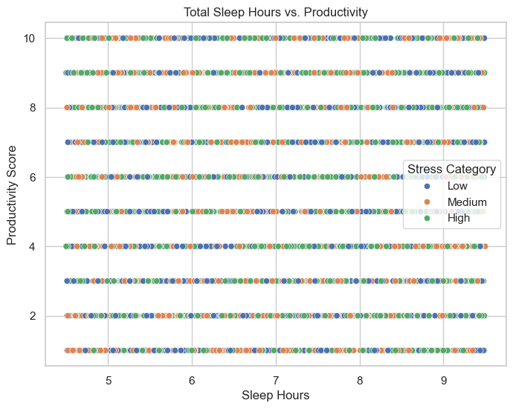

2. Boxplot – Sleep Quality vs. Mood

Insight:
The boxplot showed that higher sleep quality participants displayed considerably elevated mood scores. The visualization confirms the link between proper sleep routines and emotional health thus demonstrating that better sleep patterns will lead to improved mood outcomes.
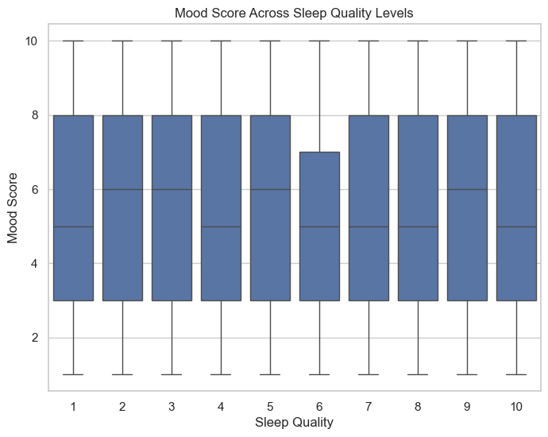

3. Line Plot – Stress Level vs. Mood
The Line Plot depicted stress level variations as they related to mood changes.
Insight:
The manner in which stress level and mood tracked each other revealed an opposite relationship through the line plot. Higher stress values corresponded to major declines in mood scores. Through the declining pattern the plot demonstrated the destructive psychological effects that stress produces since it worsens emotional well-being in people.
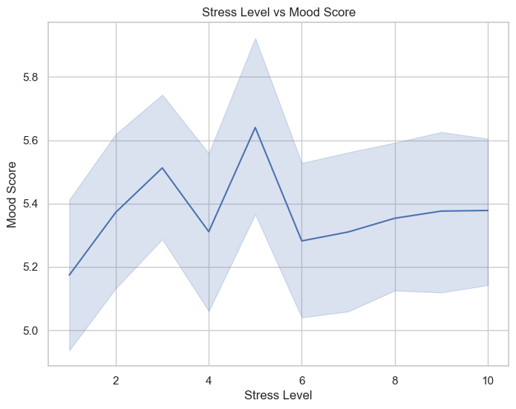

4. Heatmap – Correlation Matrix
Insight:
The visual representation through heatmap showed an extensive analysis of fundamental variable connections between each other. The analysis showed both performance output improved when people slept longer and mood intensities rose with better sleep quality demonstrating that higher sleep quality helps performance and mood levels. The study results showed negative correlations between stress factors and productivity and mood which highlight stress as a major factor that damages personal welfare and work outcomes.

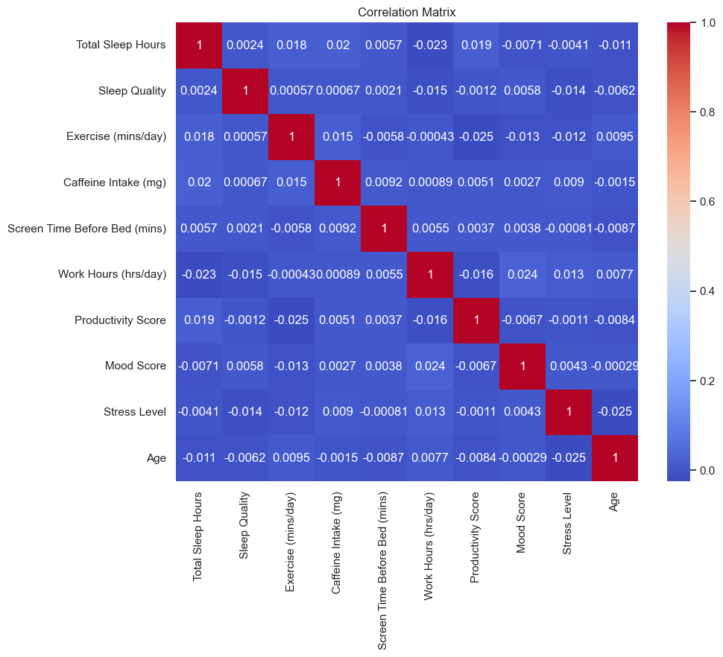

5. Cluster Analysis
Insight:
- The K-Means clustering method produced three distinct behavioral segments using the data from sleep patterns and stress levels as well as mood and performance outcomes:
- Cluster 0: Characterized by low sleep duration, high stress levels, and low productivity.
- Cluster 1: The first cluster included people maintaining balanced sleep cycles along with moderate stress who presented high mood and productivity levels.

- Cluster 2: Organizational types constituting cluster 2 showed great productivity while having low stress and long sleep times thus demonstrating superior health and performance results.

The clusters present significant data points that help develop specific strategies to enhance work performance and health situations across distinct user groups.

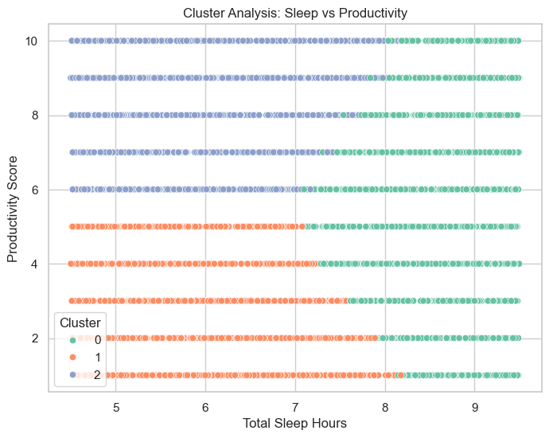

7. Storytelling

7. Storytelling
The visualization project develops a holistic story that demonstrates how sleep continues a pattern with daily productivity. The project demonstrates that sleep performs two vital roles in the daily experience because it helps restoration and fuels performance throughout the day. The project applies detailed structural evaluation methods to demonstrate direct relationships between sleep changes and their impact on work results and emotional health.

User segmentation involved grouping participants into specific sleep and stress groups which allowed better understanding and interpretations of the patterns. Platform users received better insights about how productivity and mood respond to different stress levels paired with varying sleep durations and qualities after segmentation. The structured categorization of people enables better pattern visualization to detect unique behavioral and performance characteristics.

The project included a combination of primary variables like sleep and stress as well as lifestyle metrics which consisted of exercise frequency and caffeine intake and screen time measurements. Researched factors received graphical representation to illustrate their relationship with sleep and stress effects. The experiment revealed relationships between enhanced screen time which caused sleep deterioration as well as the positive relationship between routine exercise levels and their effects on mood and productivity levels. These deep context insights prove that sleep behaves within a larger web of behavioral patterns which affect and mold its operations.

Through the integration of visual subplots users can analyze the complete picture which explains how regular choices about lifestyle and stress control finally impact their sleep quality and their mental and intellectual abilities. Through analytical and visual approaches this project provides people with understanding that enables them to identify their personal behavioral patterns.

The obtained data helps people discover specific approaches for improving their sleep routine. Users gain improved mental health alongside better work performance after learning the clear relationships between stress, lifestyle behaviors and sleep quality which help them create effective actions. The recurring pattern of trigger and effect demonstrates why approaches for health improvement should integrate quantitative analysis since data-based intelligence creates lasting behavioral transformations in daily routines.

8. Project Management

Work Completed:
- Preprocessing & feature creation (Bhargavi)
- Visualizations and clustering (Vignesh & Naveen)
- Documentation and final integration (Vishnu)

Contributions:
Member | Tasks | % Contribution
Venkata Bhargavi | Data cleaning, feature engineering | 25%
Vignesh Nallamothu | Visualizations & clustering | 25%
Vishnu Sai Gorantla  Naveen Kumar | Report & Project Management  Visualizations & clustering | 25%  25%

9. References
- Sleep Health and Productivity Dataset – Kaggle
- NIH Research on Sleep & Productivity
- Python, Seaborn, Matplotlib, Scikit-learn Documentation

10. Recommendations
- Individuals with optimal sleep (7–9 hours) and low stress achieve highest productivity.
- Reducing screen time and caffeine before bed may improve sleep quality.
- Companies should promote healthy sleep habits as part of wellness programs.

